NAME:
CPSC 361: COMPUTER SIMULATION - FINAL
Fall, 12 week, 2007
Slotterbeck

DIRECTIONS: Answer all questions on line and when finished, email to csgrader@hiram.edu with the file named as yourusername-final.doc

(MULTIPLE-CHOICE) questions may have more than one item chosen to make the statement true. All must be selected and their identifying letters listed.

For (TRUE-FALSE) questions, type true or false.

ESSAY questions are unmarked. Answers should be precise and specific to the question. Don't waste your time (and mine) saying the same thing in several different ways. There is no need to repeat the question as I wrote it and, consequently, know what it says! Essay answers can be of any length as long as the question is answered with reasons provided for the answer.

Definitions are marked as (DEFINE). Don’t provide examples, just state a definition.
=============================================================
1. Why is the statistical analysis of output so critical when doing simulations? What questions are asked typically during statistical analysis?

2. Describe how Arena uses Stations and Transfers. What can they represent? What do they allow us to do? How do they relate to time delays and when would you use them instead of a time delay?

3. It has been said that animation is the least important part of a simulation study and it has been said that animation is the most important part of a simulation study. Explain this statement.

4. Suppose I am hired to study the deli line at a local supermarket during the dinner rush. There are three servers, and each customer takes a number to assure that the customer who has been waiting the longest gets the next available server. I plan to use ARENA with a Create module to generate customers and a Dispose module to record statistics as they leave. Which of the following is the best way to model the three servers? Describe the reason for your choice.

- one SERVER, capacity 3
- three SERVERs
- None of the above; I must use the SETS module

5. Suppose I am hired to study the deli line at a local supermarket during the dinner rush. There are three servers, and each customer takes a number to assure that the customer who has been waiting the longest gets the next available server.

a. I am not able to obtain actual data for the time between arrivals of the customers, but interviews of the manager reveal that the average time between customers during the dinner rush is about 1.5 minutes, but many more than half of the interarrival times are less than 1.5 minutes. Which of the following is the best distribution to use? Justify your answer. (Hint: Think of the shape of these curves and relate that to the data provided.)

- UNIF(.5,2)
- TRIA(1,1.5,5)
- TRIA(.5,1.5,2)
- EXPO(1.5)

b. I do have data collected on how long each server spent with each customer. I have a data set with approximately 1000 service times recorded. What is the best way for me to use this data in my simulation assuming I want to model both current and possible future configurations of servers?

6. Name 3 general-purpose simulation languages. Do not specify any general-purpose language or Arena.

7. Briefly describe why simulations are often used instead of mathematical queueing theory.

8. Suppose I want to model the “walk-in” HELP Desk for the Computing Center between 2:00 and 6:00 PM on a weekday. During this time, there is normally one person working. While she is with a customer, occasionally she is called away to take a phone call. When this happens, she always finishes with the customer she is working with before she takes the call. I will model a phone call as a “FAILURE” since the HELP Desk has capacity zero while the worker is on the phone. Should I use WAIT, IGNORE, or PREEMPT? Explain both why you chose the one you did and why you rejected the other two choices.

9. DEFINE:
a. A simulation
a. Event-driven simulation, assuming (a) is defined
b. Process-driven simulation, assuming (a) is defined
c. A system
d. The state of a system
e. Validation of a model
f. Verification of a model

10. A person has pumped data into Arena's Input Analyzer and tested the goodness of fit for a Weibull distribution with three different results shown below. What feedback would you provide to the person who wants to see if the fit is good or poor? Be specific and explain your reasoning for each of the situations a-c below:

a.Distribution summary:
Distribution: Weibull
Expression: 1 + WEIB(45.1,1.1)
Square Error: 0.050989
Chi Square Test Kolmogorov-Smirnov Test
Number of intervals = 4 Test Statistic = 0.375
Degrees of freedom = 1 Corresponding p-value = 0.47
Test Statistic = 7.22
Corresponding p-value = 0.27

b. Distribution summary:
Distribution: Weibull
Expression: 1 + WEIB(45.1,1.1)
Square Error: 0.050989
Chi Square Test Kolmogorov-Smirnov Test
Number of intervals = 4 Test Statistic = 0.375
Degrees of freedom = 1 Corresponding p-value = 0.00002
Test Statistic = 7.22
Corresponding p-value = 0.00001

c. Distribution summary:
Distribution: Weibull
Expression: 1 + WEIB(45.1,1.1)
Square Error: 0.080989
Chi Square Test Kolmogorov-Smirnov Test
Number of intervals = 4 Test Statistic = 0.475
Degrees of freedom = 1 Corresponding p-value = 9.047
Test Statistic = 8.22
Corresponding p-value = 3.021

11. DEFINE, in the context of OptQuest:
a. A control
b. A response
c. A constraint
d. An objective

12. Suppose a simulation model for a bookstore during book buying is built. After 50 replications of a nine-hour day, a 95% confidence interval is found for the average time a student spends standing in line. In particular, we can say we are 95% sure that the expected average time a student spends in line is somewhere between 5.42 and 9.48 minutes. Explain what is meant by this statement, particularly the "95% part".

13. Consider the following produced by the output analyzer where the two means being analyzed represents the expected difference Total Cost and Percent Rejected between the Base Case and the More Resources case.

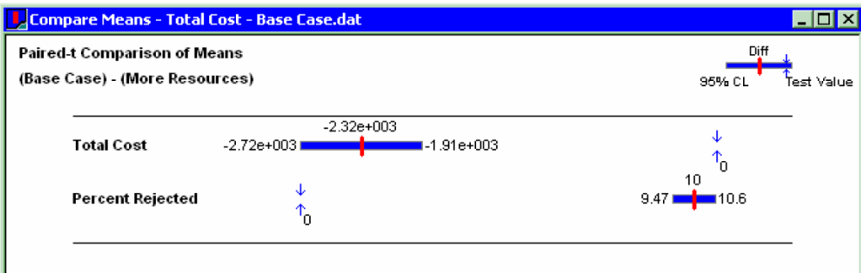

a. Can we conclude that the expected Total Cost of the More Resources system is different than the expected Total Cost of the Base Case system? If yes, is the difference statistically significant? Why or why not?

b. Can we conclude that the expected Percent Rejected of the More Resources system is different than the expected Percent Rejected of the Base Case system? If yes, is the difference statistically significant? Why or why not?

14. Suppose you are asked to simulate a network and analyze the mean system time. After we have run 10 replications, the 95% confidence interval is [0.8,1.2]. If our goal is to obtain a smaller confidence interval of length 0.2, should we run more replications and, if yes, how many would be specified by the back-of-the-envelope calculation introduced in class?

15. (MULTIPLE-CHOICE) The Process Analyzer (PAN) in Arena
a. Allows you to compare many alternatives at the same time.
b. PAN operates on the compiled program files with the extension .doe.
c. In PAN, you create scenarios that use input controls and output responses.
d. PAN provides many possible graphs showing how different alternatives compare.
e. PAN automatically selects an optimal alternative.
f. None of the above.

16. (MULTIPLE-CHOICE) OptQuest
a. Searches for an optimal solution using heuristic search methods.
b. Is guaranteed to provide an optimal alternative from a specified set of alternatives.
c. Was written by the same people that provided the Arena software.
d. Can take a very long time to run if you are presenting it with many alternatives and you don't choose your bounds properly.
e. None of the above
17. Exercise 06-15 models an airport security system with a checkers designated as Manual, Automated, and Security. This analysis considered the question, "If you could hire one more person, and that person could be assigned either to Manual, Automated, or Security, where would this person be best used based on the average total time in the system of all types of passengers combined." Consider the following output Describe how this analysis was performed and discuss all the information and conclusions conveyed below

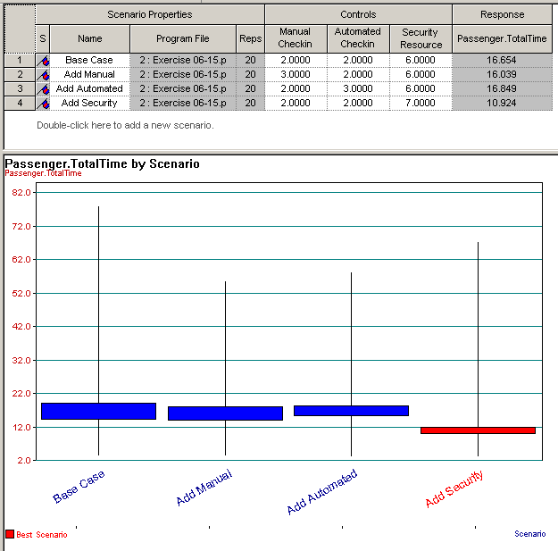

18. Exercise 06-16 models an airport security system with checkers designated as Manual, Automated, and Security. This analysis considered the question, "If you could hire a total of five more people to be allocated in any way to the existing staff at Manual, Automated, or Security, what would be the best deployment of these people, assuming you can't reduce below the original levels." Consider the following output Describe how this analysis was performed and discuss all the information and conclusions conveyed below

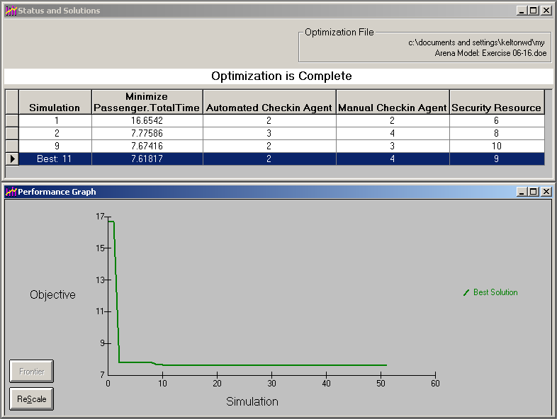

19.Suppose we want to model the "walk-in" HELP desk for a computer center between 2:00 and 6:00 PM on a weekday. During this time, there is normally one person working. When that person is with a customer, (s)he can be called away to take a phone call. When this happens, (s)he always finishes with the current customer before taking the call. Discuss the difference between the use of WAIT, IGNORE, or PREEMPT for reducing capacity in this setting. Which would you choose and why?

20. (TRUE-FALSE) When building a simulation model in Arena, the modeler uses process-driven simulation techniques.

21. (TRUE-FALSE) Arena processes models using process-driven procedures.

22. DEFINE:
a) Sample space b) Event

23. Give the sample space when three coins are tossed. Assume an H is recorded for a head and a T is recorded for a tail. Assume the coins are not biased.

24. (MULTIPLE CHOICE) If A and B are events, the symbol P(A|B) is
a) The probability that B occurs given that A has occurred.
b) P(A)P(B)/P(A ∩ B)
c) A conditional probability.
d) P(A ∩ B)/P(B), assuming P(B) ≠ 0
e) None of the above

25. (MULTIPLE CHOICE ) Saying that two events A and B are independent means
a) Knowing one of the events has occurred does not tell us anything about the probability of the other event occurring.
b) A and B are mutually exclusive.
c) P(A ∩ B) = P(A)P(B)
d) B always occurs whenever A occurs.
e) None of the above

26. (MULTIPLE CHOICE) Saying that a distribution has expected value λ assumes that
a) The value λ is expected to be seen more than any other.
b) We have sampled infinitely many times.
c) The average of all values observed is λ.
d) The average of any finite number of values seen will be exactly λ.
e) None of the above

27. (TRUE-FALSE) The period of a pseudorandom number generator should be short in order to guarantee randomness.

28. (TRUE-FALSE) The primary reason for having different streams of pseudorandom numbers is to avoid nonrandom sequences.

29. (TRUE-FALSE) Pseudorandom number streams are just different starting points in a sequence of pseudorandom numbers.

30. (TRUE-FALSE) As we make more and more replications, a confidence interval for the mean tends to become shorter and shorter.

31. Suppose we have built a model and we have found that the average service time is strictly less than the average interarrival time. Briefly discuss what you might see when the model runs. Are you guaranteed to see what you claim? Support your claims by giving reasons or examples.

32. Suppose the event calendar in Arena is:
[3, 9.24, Arr]
[2, 9.80, Dep]
[-, 15.00, End]
and we have a simple model with a Create module, Process module, Dispose module as in our first class example. Assume the following interarrival and service times:

Interarrival times | 6.84 2.40 2.70 2.59 0.73
Service times | 4.91 3.09 6.45 3.40 3.25

a. What is the next event that will occur and when will it occur?

b. After the next event has occurred, what will happen next and how will the event calendar change? Show the new event calendar.

HAVE A NICE BREAK!
LOOK FOR EMAIL WHEN YOU COME BACK FOR
PICKING UP THIS TEST AND ANY OTHER WORK I HAVE!

